Visual Systems make information quickly and easily available to everyone. Visual systems can:
- Communicate with simple visual cues
- Tell us at a glance how we’re doing
- Signal us that action needs to be taken
- Support process standardization

Visual Management:

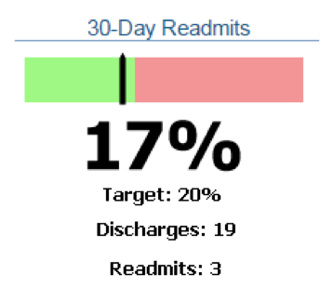

Visual Controls/Visual Workplace:

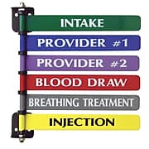

Visual Planning:

